INDEX

1. BLINKING LED 2

2. FADING LED 5

3. HUMIDITY SENSOR 8

4. PIR SENSOR 12

5. ULTRASONIC SENSOR 17

6. SOIL MOISTURE SENSOR 21

A .SOIL MOISTURE MEASUREMENT USING ANALOG PIN A0 22

B. SOIL MOISTURE MEASUREMENT USING DIGITAL PIN 12 23

C. WATER LEVEL MEASUREMENT USING SOIL MOISTURE SENSOR 23

7. PUSH BUTTON AND LED 25

8. TRAFFIC LIGHTS 30

## BLINKING LED

**AIM:** To write a program for blinking of an LED.

**DESCRIPTION:** LEDs are small, powerful lights that are used in many different applications. To start, we will work on blinking an LED using of microcontrollers. It is as simple as turning a light on and off. Establishing this important baseline will give you a solid foundation as we work towards experiments that are more complex.  
**Components Required**  
You will need the following components -  
• 1x Breadboard  
• 1x Arduino Uno R3  
• 1x LED  
• 1x 330Ω Resistor  
• 2x Jumper  
**Procedure**  
Follow the circuit diagram and hook up the components on the breadboard as shown in the image given below.

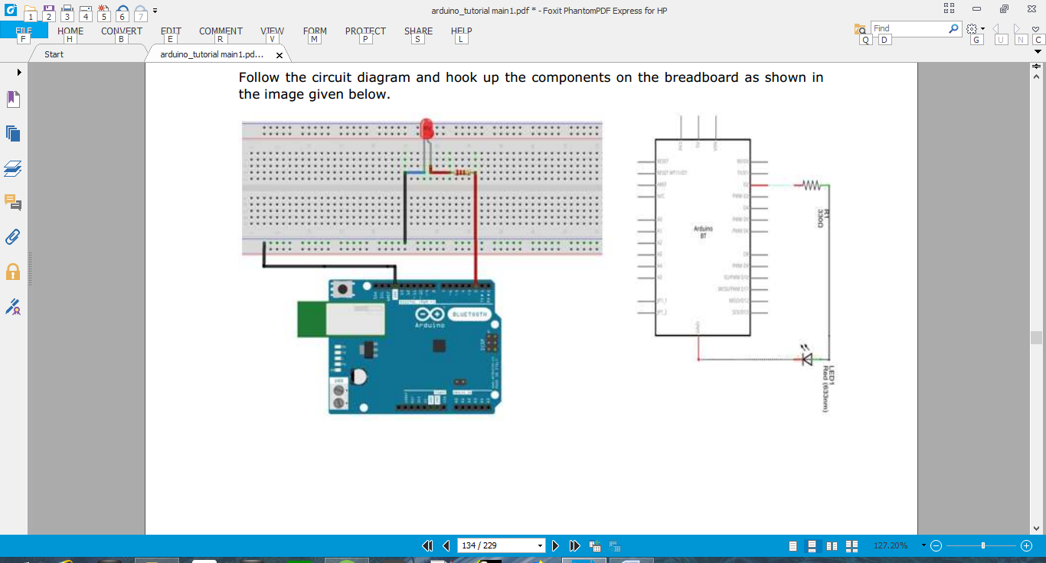

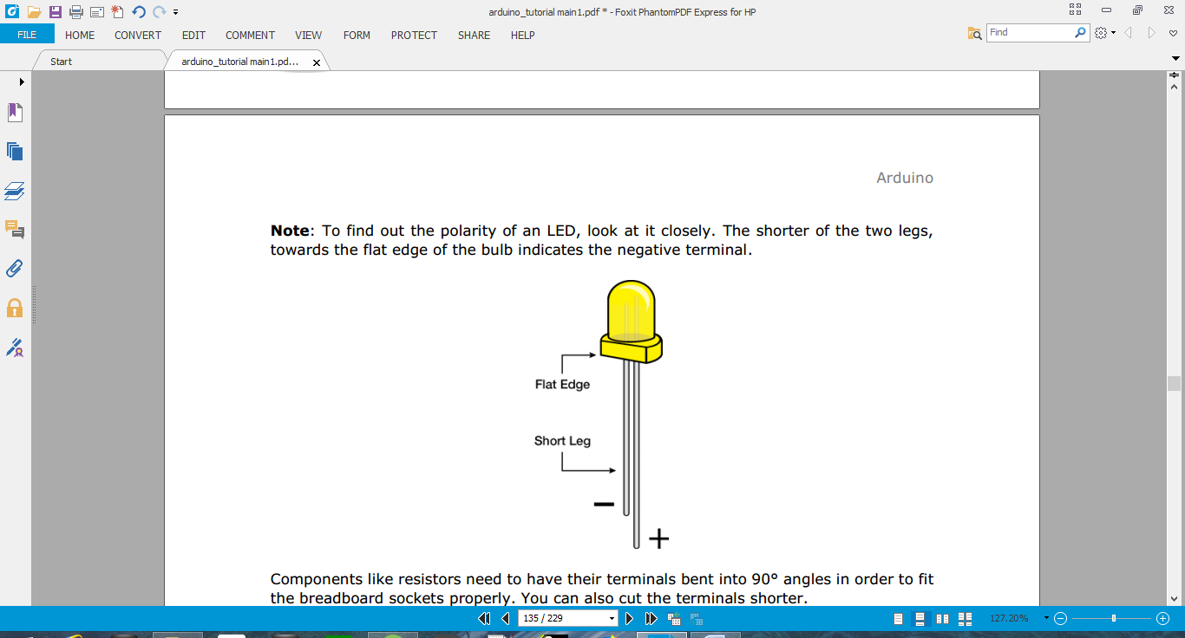

Components like resistors need to have their terminals bent into 90° angles in order to fit the breadboard sockets properly. You can also cut the terminals shorter.

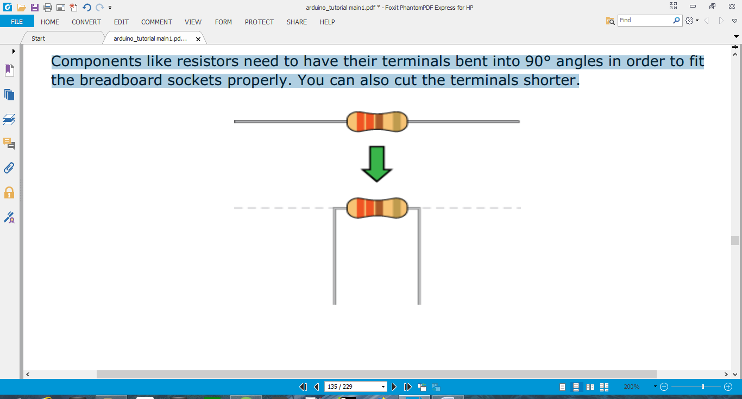

**Sketch**  
Open the Arduino IDE software on your computer. Coding in the Arduino language will control your circuit. Open the new sketch File by clicking New.

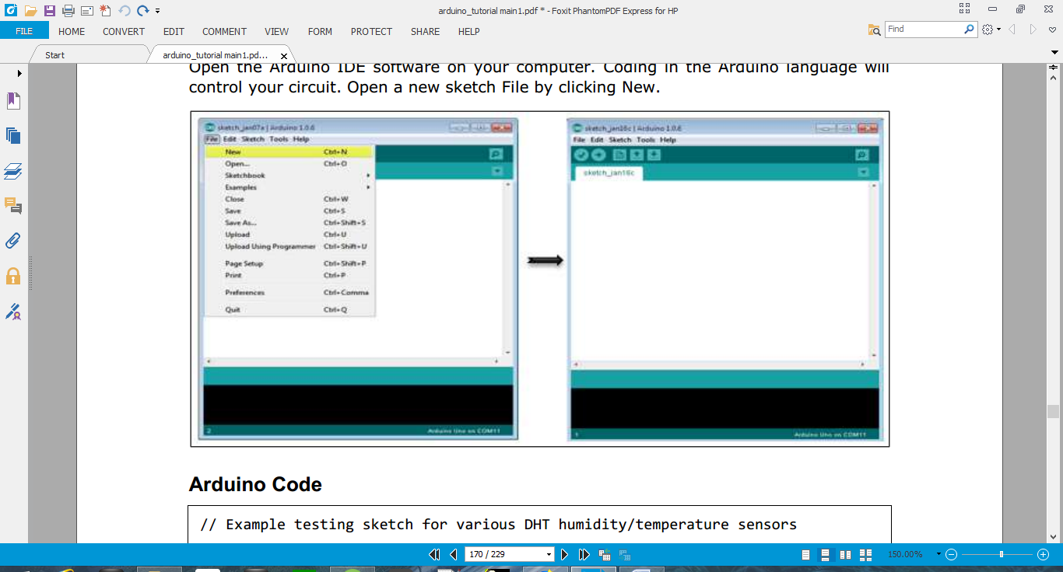

**AUDINO CODE:**

/*  
Blink  
Turns on an LED on for one second, then off for one second, repeatedly.  
*/  
// the setup function runs once when you press reset or power the board  
void setup()  
{  
// initialize digital pin 13 as an output.  
pinMode( 13, OUTPUT);  
}  
// the loop function runs over and over again forever  
void loop()  
{  
digitalWrite( 13, HIGH); // turn the LED on (HIGH is the voltage level)  
delay(1000); // wait for a second  
digitalWrite( 13, LOW); // turn the LED off by making the voltage LOW  
delay(1000); // wait for a second  
}

**Code to Note**  
**pinMode(2, OUTPUT) -** Before you can use one of Arduino’s pins, you need to tell ArduinoUno R3 whether it is an INPUT or OUTPUT. We use a built-in “function” called pinMode() to do this.  
**digitalWrite(2, HIGH) -** When you are using a pin as an OUTPUT, you can command it to be HIGH (output 5 volts), or LOW (output 0 volts).  
**Result**  
You should see your LED turn on and off. If the required output is not seen, make sure you have assembled the circuit correctly, and verified and uploaded the code to your board.

## FADING LED

**AIM:** To write a program for fading a LED.

**DESCRIPTION:**

This example demonstrates the use of the analogWrite() function in fading an LED off. AnalogWrite uses pulse width modulation (PWM), turning a digital pin on and off very quickly with different ratios between on and off, to create a fading effect.  
**Components Required**  
You will need the following components-  
• 1x Breadboard  
• 1x Arduino Uno R3  
• 1x LED  
• 1x 330Ω Resistor  
• 2x Jumper  
**Procedure**  
Follow the circuit diagram and hook up the components on the breadboard as shown in the image given below.



**Note:** To find out the polarity of an LED, look at it closely. The shorter of the two legs towards the flat edge of the bulb indicates the negative terminal.



Components like resistors need to have their terminals bent into 90° angles in order to fit the breadboard sockets properly. You can also cut the terminals shorter.



**Sketch**  
Open the Arduino IDE software on your computer. Coding in the Arduino language will control your circuit. Open a new sketch File by clicking on New.

  
**Arduino Code**  
/*  
Fade  
This example shows how to fade an LED on pin 9vusing the analogWrite() function.  
The analogWrite() function uses PWM, so if you want to change the pin you're using, be sure to use another PWM capable pin. On most Arduino, the PWM pins are identified with a "~" sign, like ~3, ~5, ~6, ~9, ~10 and ~11.  
*/  
**int led = 9**; // the PWM pin the LED is attached to **int brightness = 0;** // how bright the LED is **int fadeAmount = 5;** // how many points to fade the LED by  
// the setup routine runs once when you press reset: **void setup()  
{**// declare pin 9 to be an output: **pinMode( led, OUTPUT);  
}**// the loop routine runs over and over again forever: **void loop()  
{**// set the brightness of pin 9: **analogWrite( led, brightness);**// change the brightness for next time through the loop:  
**brightness = brightness + fadeAmount;**// reverse the direction of the fading at the ends of the fade:  
**if (brightness == 0 || brightness == 255)  
{  
fadeAmount = -fadeAmount ;  
}**// wait for 30 milliseconds to see the dimming effect **delay(300);  
}  
Code to Note**  
  
**analogWrite()** can change the PWM value very fast, so the delay at the end of the sketch controls the speed of the fade. Try changing the value of the delay and see how it changes the fading effect.  
**Result**  
You should see your LED brightness change gradually.

## HUMIDITY SENSOR

**AIM:** to write a program for finding the room temperature using humidity sensor.

**DESCRIPTION:**

In this section, we will learn how to interface our Arduino board with different sensors. We will discuss the following sensors -  
• Humidity sensor (DHT11)  
• Temperature sensor (LM35)  
• Water detector sensor (Simple Water Trigger)  
• PIR SENSOR  
• ULTRASONIC SENSOR  
• GPS  
**Humidity Sensor (DHT11)**  
The DHT-22 (also named as AM2302) is a digital-output, relative humidity, and temperature sensor. It uses a capacitive humidity sensor and a thermistor to measure the surrounding air, and sends a digital signal on the data pin. In this example, you will learn how to use this sensor with Arduino UNO. The room temperature and humidity will be printed to the serial monitor.  
**The DHT-11 Sensor**

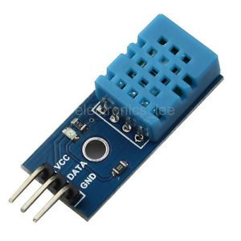  
The connections are simple. The first pin on the left to 3-5V power, the second pin to the data input pin and the right-most pin to the ground.  
**Technical Details**  
• **Power**: 3-5V  
• **Max Current**: 2.5mA  
• **Humidity**: 0-100%, 2-5% accuracy  
• **Temperature**: -40 to 80°C, ±0.5°C accuracy  
**Components Required**  
You will need the following components:  
• 1x Breadboard  
• 1x Arduino Uno R3  
• 1x DTH11  
• 1X10K ohm resistor  
**Procedure**  
Follow the circuit diagram and hook up the components on the breadboard as shown in the image below.

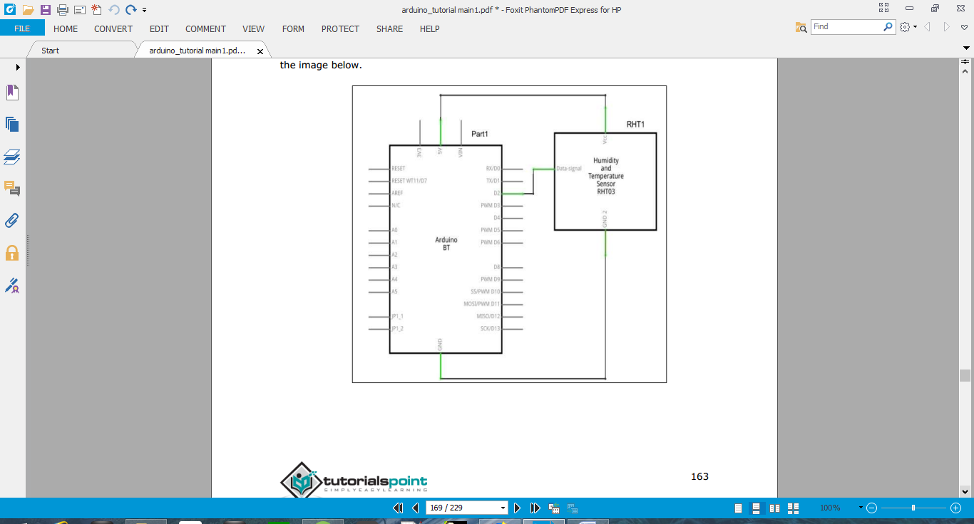

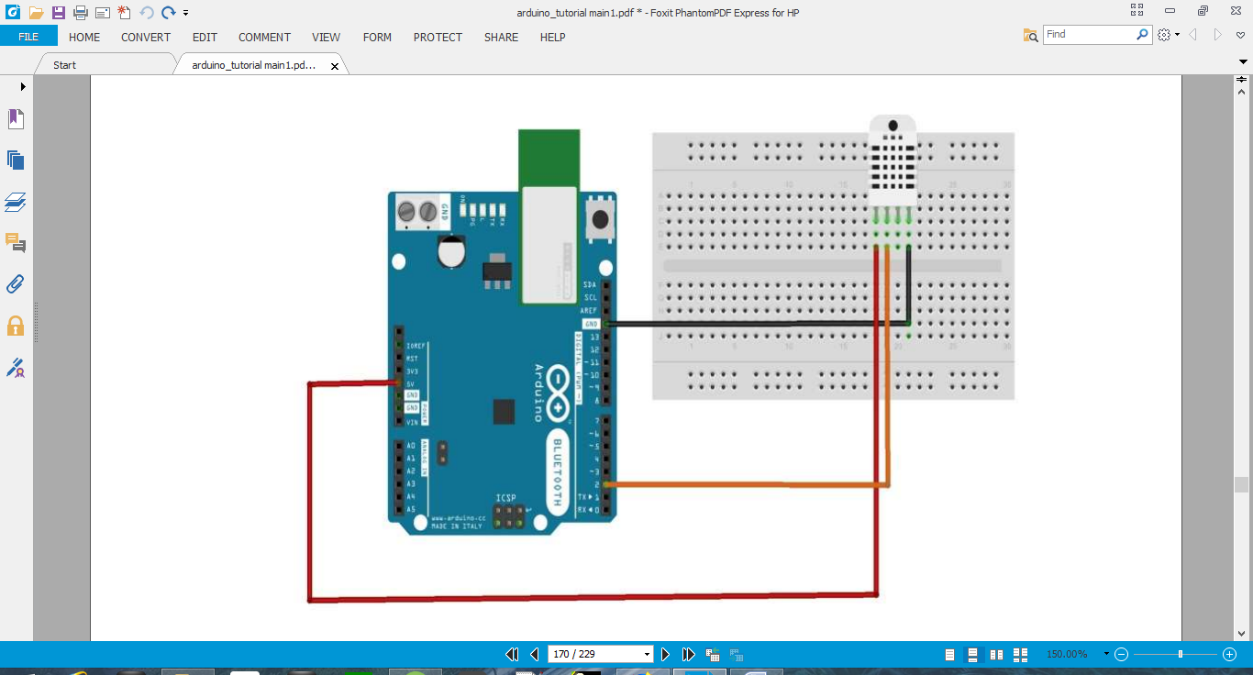  
**Sketch**  
Open the Arduino IDE software on your computer. Coding in the Arduino language will control your circuit. Open a new sketch File by clicking New.



**Arduino Code**  
// Example testing sketch for various DHT humidity/temperature sensors  
#include "DHT.h"  
#define DHTPIN 2 // what digital pin we're connected to  
// Uncomment whatever type you're using!  
**#define DHTTYPE DHT11 // DHT 11  
//#define DHTTYPE DTH22 // DHT 22 (AM2302), AM2321  
//#define DHTTYPE DHT21 // DHT 21 (AM2301)**// Connect pin 1 (on the left) of the sensor to +5V  
// NOTE: If using a board with 3.3V logic like an Arduino Due connect pin 1  
// to 3.3V instead of 5V!  
// Connect pin 2 of the sensor to whatever your DHTPIN is  
// Connect pin 4 (on the right) of the sensor to GROUND  
// Connect a 10K resistor from pin 2 (data) to pin 1 (power) of the sensor  
// Initialize DHT sensor.  
// Note that older versions of this library took an optional third parameter to  
// tweak the timings for faster processors. This parameter is no longer needed  
// as the current DHT reading algorithm adjusts itself to work on faster procs.  
DHT dht(DHTPIN, DHTTYPE);  
void setup() {  
Serial.begin(9600);  
Serial.println("DHTxx test!");  
dht. begin();  
}  
void loop() {  
delay(2000); // Wait a few seconds between measurements  
float h = dht.readHumidity();  
// Reading temperature or humidity takes about 250 milliseconds!  
float t = dht. readTemperature();  
// Read temperature as Celsius (the default)  
float f = dht.readTemperature(true);  
// Read temperature as Fahrenheit (isFahrenheit = true)  
// Check if any reads failed and exit early ( to try again).  
if (isnan(h) || isnan(t) || isnan(f))  
{  
Serial.println("Failed to read from DHT sensor!") ;  
return;  
}  
// Compute heat index in Fahrenheit (the default)  
float hif = dht. computeHeatIndex(f, h);  
// Compute heat index in Celsius (isFahreheit = false)  
float hic = dht.computeHeatIndex(t, h, false);  
Serial.print ("Humidity: " );  
Serial.print (h);  
Serial.print (" %\t");  
Serial.print ("Temperature: " );  
Serial.print (t);  
Serial.print (" *C ") ;  
Serial.print (f) ;  
Serial.print (" *F\t");  
Serial.print ("Heat index: ");  
Serial.print (hic);  
Serial.print (" *C ");  
Serial.print (hif);  
Serial.println (" *F");  
}  
**Code to Note**  
DTH11 sensor has four terminals (Vcc, DATA, NC, GND), which are connected to the board  
as follows:  
• DATA pin to Arduino pin number 2  
• Vcc pin to 5 volt of Arduino board  
• GND pin to the ground of Arduino board  
• We need to connect 10k ohm resistor (pull up resistor) between the DATA and the Vcc pin Once hardware connections are done, you need to add DTH11 library to your Arduino library file as described earlier  
**Result**  
You will see the temperature and humidity display on serial port monitor which is updated every 2 seconds.

## PIR SENSOR

**AIM:** To write a program to perform PIR sensor.

**DESCRIPTION:**

PIR sensors allow you to sense motion. They are used to detect whether a human has moved in or out of the sensor’s range. They are commonly found in appliances and gadgets used at home or for businesses. They are often referred to as PIR, "Passive Infrared", "Pyroelectric", or "IR motion" sensors.  
Following are the advantages of PIR Sensors -  
• Small in size  
• Wide lens range  
• Easy to interface  
• Inexpensive  
• Low-power  
• Easy to use  
• Do not wear out

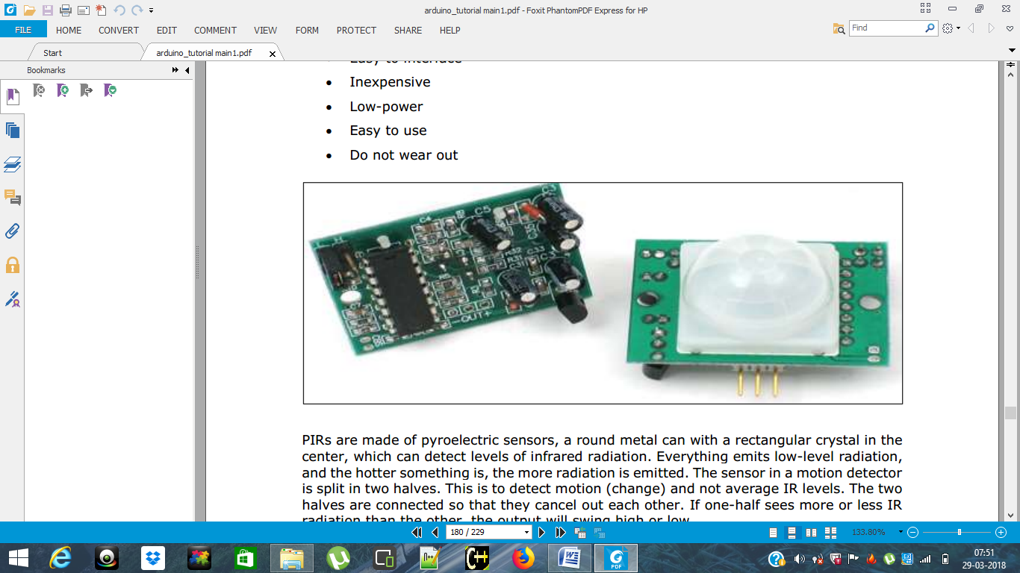  
PIRs are made of pyroelectric sensors, a round metal can with a rectangular crystal in the center, which can detect levels of infrared radiation. Everything emits low-level radiation, and the hotter something is, the more radiation is emitted. The sensor in a motion detector is split in two halves. This is to detect motion (change) and not average IR levels. The two  
halves are connected so that they cancel out each other. If one-half sees more or less IR radiation than the other, the output will swing high or low.

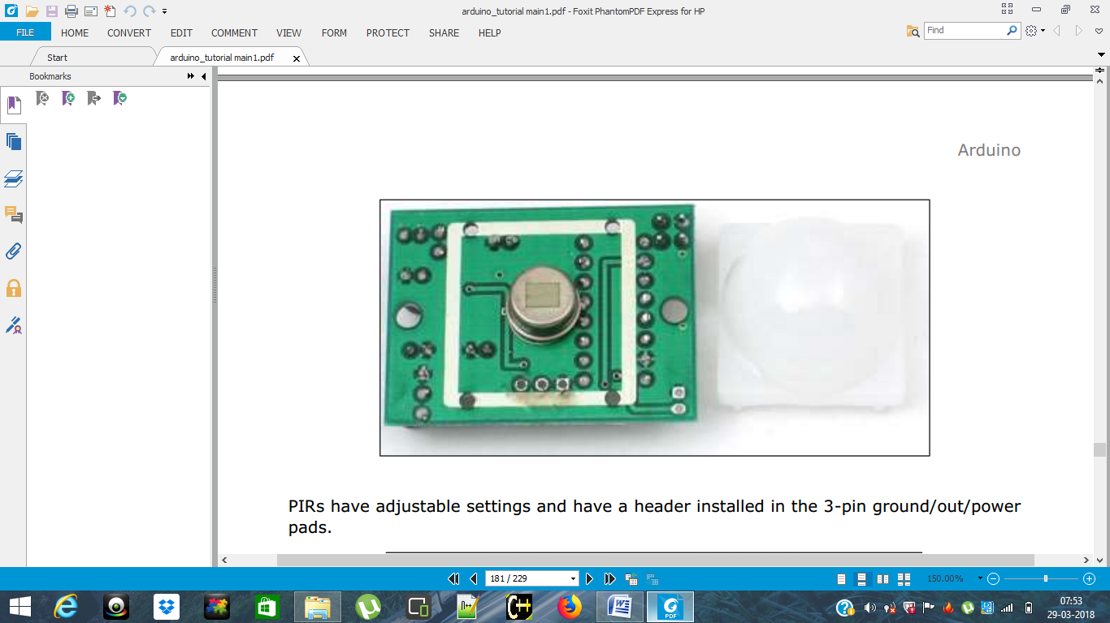

PIRs have adjustable settings and have a header installed in the 3-pin ground/out/power pads.

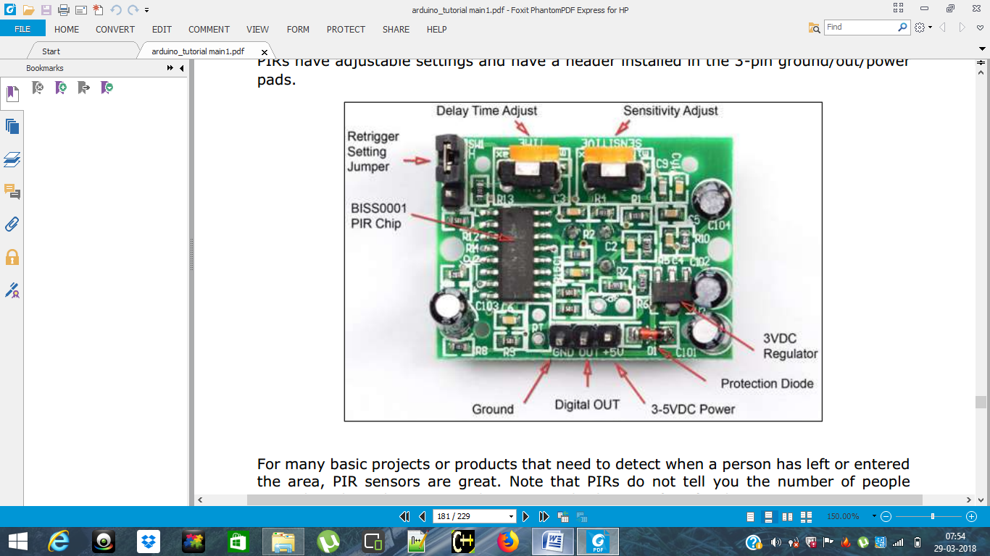

For many basic projects or products that need to detect when a person has left or entered the area, PIR sensors are great. Note that PIRs do not tell you the number of people around or their closeness to the sensor. The lens is often fixed to a certain sweep at a  
distance and they are sometimes set off by the pets in the house.  
**Components Required**  
You will need the following components:  
• 1x Breadboard  
• 1x Arduino Uno R3  
• 1x PIR Sensor (MQ3)  
**Procedure**  
Follow the circuit diagram and make the connections as shown in the image below.

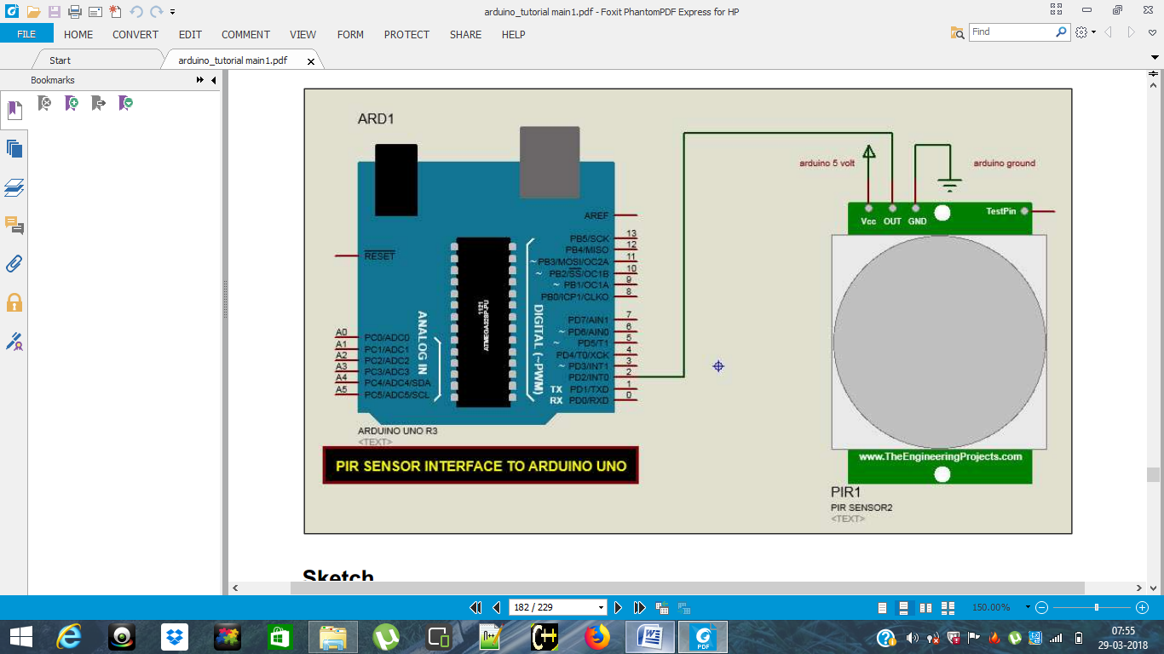

**Sketch**  
Open the Arduino IDE software on your computer. Coding in the Arduino language will control your circuit. Open a new sketch File by clicking New.

  
**Arduino Code**

1. void setup() {

pinMode(2, INPUT); //Pin 2 as INPUT

pinMode(3, OUTPUT); //PIN 3 as OUTPUT

}

void loop() {

if (digitalRead(2) == HIGH)

{

digitalWrite(3, HIGH); // turn the LED/Buzz ON

delay(100); // wait for 100 msecond

digitalWrite(3, LOW); // turn the LED/Buzz OFF

delay(100); // wait for 100 msecond

}

}

2. #define pirPin 2  
int calibrationTime = 30;  
long unsigned int lowIn;  
long unsigned int pause = 5000;  
boolean lockLow = true;  
boolean takeLowTime;  
int PIRValue = 0;  
void setup()  
{  
Serial.begin(9600);  
pinMode( pirPin, INPUT);  
}  
void loop()  
{  
PIRSensor();  
}  
void PIRSensor()  
{  
if(digitalRead(pirPin) == HIGH)  
{  
if(lockLow)  
{  
PIRValue = 1;  
lockLow = false;  
Serial.println("Motion detected." );  
delay(50);  
}  
takeLowTime = true;  
}  
if(digitalRead(pirPin) == LOW)  
{  
if(takeLowTime){lowIn = millis(); takeLowTime = false;}  
if(!lockLow && millis() - lowIn > pause)  
{  
PIRValue = 0;  
lockLow = true;  
Serial.println("Motion ended." );  
delay(50);  
}  
}  
}

**Code to Note**  
PIR sensor has three terminals - Vcc, OUT and GND. Connect the sensor as follows:  
• Connect the +Vcc to +5v on Arduino board.  
• Connect OUT to digital pin 2 on Arduino board.  
• Connect GND with GND on Arduino.  
You can adjust the sensor sensitivity and delay time via two variable resistors located at the bottom of the sensor board. Once the sensor detects any motion, Arduino will send a message via the serial port to say that a motion is detected. The PIR sense motion will delay for certain time to check if there is a new motion. If there is no motion detected, Arduino will send a new message saying that the motion has ended.  
**Result**  
You will see a message on your serial port if a motion is detected and another message when the motion stops.

## ULTRASONIC SENSOR

**AIM:** To write a program to measure distance of object using ULTRASONIC sensor

**DESCRIPTION:**

The HC-SR04 ultrasonic sensor uses SONAR to determine the distance of an object just like the bats do. It offers excellent non-contact range detection with high accuracy and stable readings in an easy-to-use package from 2 cm to 400 cm or 1” to 13 feet. The operation is not affected by sunlight or black material, although acoustically, soft materials like cloth can be difficult to detect. It comes complete with ultrasonic transmitter and receiver module.

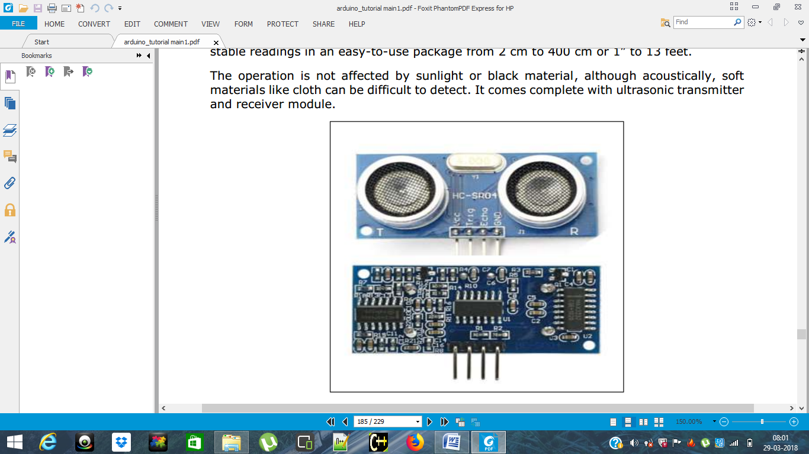 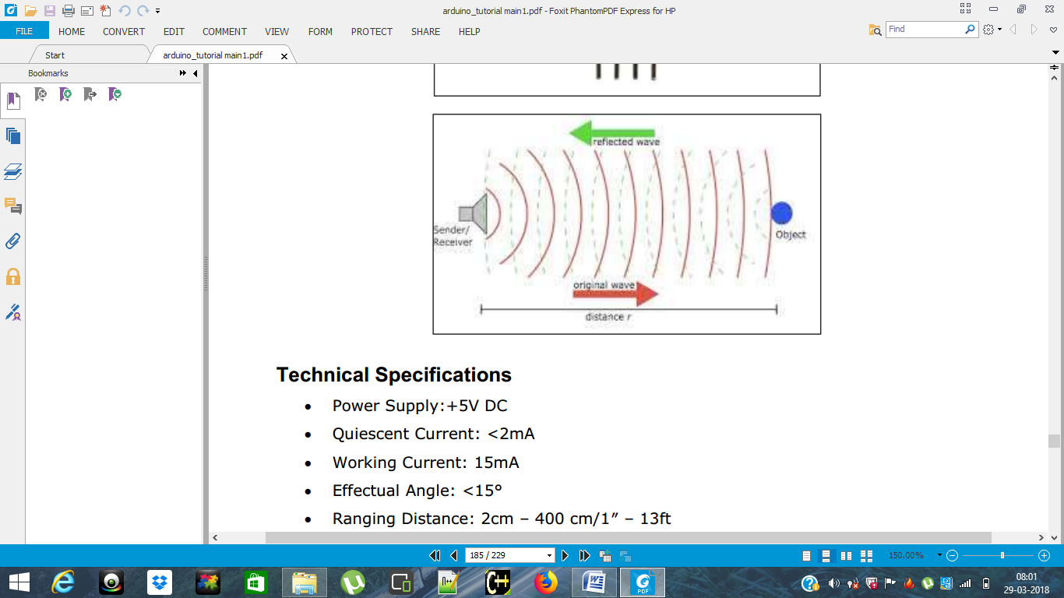

**Technical Specifications**  
• Power Supply:+5V DC  
• Quiescent Current: <2mA  
• Working Current: 15mA  
• Effectual Angle: <15°  
• Ranging Distance: 2cm – 400 cm/1″ – 13ft  
• Resolution: 0.3 cm  
• Measuring Angle: 30 degree  
**Components Required**  
You will need the following components:  
• 1x Breadboard  
• 1x Arduino Uno R3  
• 1x ULTRASONIC Sensor (HC-SR04)

**Procedure**  
Follow the circuit diagram and make the connections as shown in the image given below.

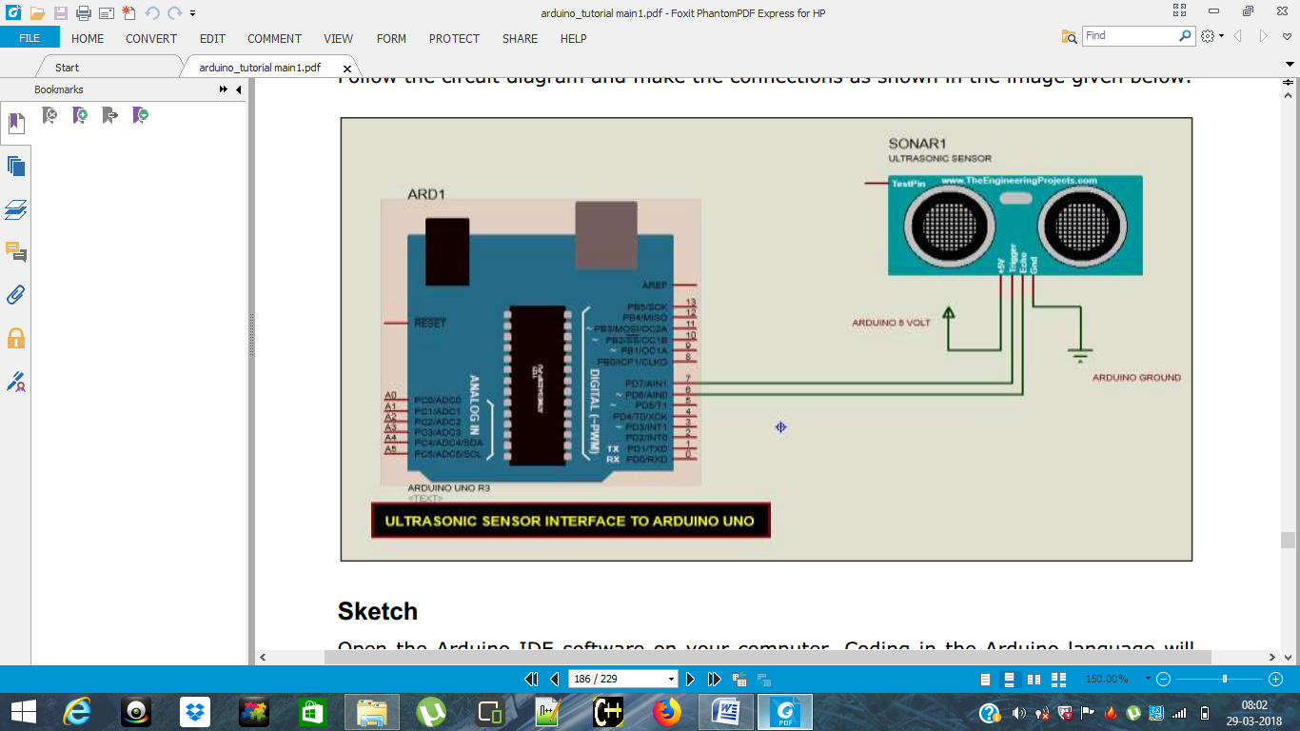  
**Sketch**  
Open the Arduino IDE software on your computer. Coding in the Arduino language will control your circuit. Open a new sketch File by clicking New.

  
**Arduino Code**  
1. const int trigPin = 9;

const int echoPin = 10;

// defines variables

long duration;

int distance;

void setup() {

pinMode(trigPin, OUTPUT); // Sets the trigPin as an Output

pinMode(echoPin, INPUT); // Sets the echoPin as an Input

Serial.begin(9600); // Starts the serial communication

}

void loop() {

// Clears the trigPin

digitalWrite(trigPin, LOW);

delayMicroseconds(2);

// Sets the trigPin on HIGH state for 10 micro seconds

digitalWrite(trigPin, HIGH);

delayMicroseconds(10);

digitalWrite(trigPin, LOW);

// Reads the echoPin, returns the sound wave travel time in microseconds

duration = pulseIn(echoPin, HIGH);

// Calculating the distance

distance= duration*0.034/2;

// Prints the distance on the Serial Monitor

Serial.print("Distance: ");

Serial.println(distance);

}

1. const int pingPin = 7; // Trigger Pin of Ultrasonic Sensor  
   const int echoPin = 6; // Echo Pin of Ultrasonic Sensor  
   void setup()  
   {  
   Serial.begin(9600); // Starting Serial Terminal  
   }  
   void loop()  
   {  
   long duration, inches, cm;  
   pinMode(pingPin, OUTPUT);  
   digitalWrite(pingPin, LOW);  
   delayMicroseconds(2);  
   digitalWrite(pingPin, HIGH);  
   delayMicroseconds(10);  
   digitalWrite(pingPin, LOW);  
   pinMode(echoPin, INPUT);  
   duration = pulseIn(echoPin, HIGH);  
   inches = microsecondsToInches(duration);  
   cm = microsecondsToCentimeters(duration);  
   Serial.print(inches);  
   Serial.print("in, ");  
   Serial.print(cm);  
   Serial.print("cm");  
   Serial.println();  
   delay(100);  
   }  
   long microsecondsToInches(long microseconds)  
   {  
   return microseconds / 74 / 2;  
   }  
   long microsecondsToCentimeters(long microseconds)  
   {  
   return microseconds / 29 / 2;  
   }  
   **Code to Note**  
   The Ultrasonic sensor has four terminals - +5V, Trigger, Echo, and GND connected as follows:  
   • Connect the +5V pin to +5v on your Arduino board.  
   • Connect Trigger to digital pin 7 on your Arduino board.  
   • Connect Echo to digital pin 6 on your Arduino board.  
   • Connect GND with GND on Arduino.  
   In our program, we have displayed the distance measured by the sensor in inches and cm 4 via the serial port.  
   **Result**  
   You will see the distance measured by sensor in inches and cm on Arduino serial monitor.

## SOIL MOISTURE SENSOR

AIM: To write a program to measure the plant and garden water level.

DESCRIPTION: This moisture sensor can read the amount of moisture present in the soil surrounding it. It's a low tech sensor, but ideal for monitoring an urban garden, or your pet plant's water level. This is a must have tool for a connected garden! This sensor uses the two probes to pass current through the soil, and then it reads that resistance to get the moisture level. More water makes the soil conduct electricity more easily (less resistance), while dry soil conducts electricity poorly (more resistance). It will be helpful to remind you to water your indoor plants or to monitor the soil moisture in your garden.

Required equipment:

Power supply: 3.3v or 5v

•Output voltage signal: 0~4.2v

•Current: 35mA

•Pin definition: Analog output(Blue wire)

GND(Black wire)

Power(Red wire)

•Size: 60x20x5mm

•Value range: 0 ~300 : dry soil

300~700 : humid soil

700~950 : in water

* Arduino
* moisture sensor
* cables  
  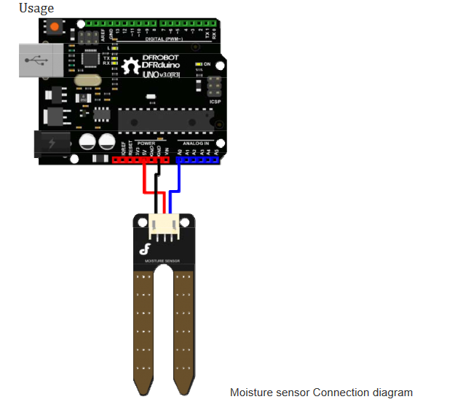

**PROCEDURE:**  
The programming of the moisture sensor isn't that complicated and is very similar to the programming of the potentiometer, because there is just an analog value read out.

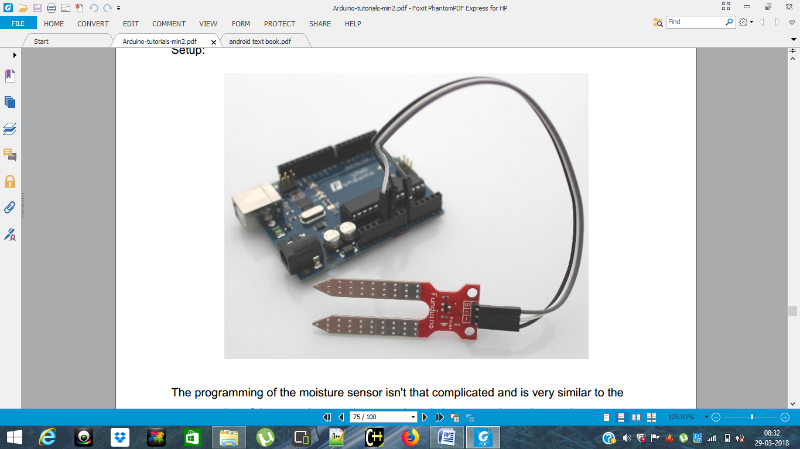  
**AUDINO CODE:**

## 6.a.SOIL MOISTURE MEASUREMENT USING ANALOG PIN A0

Connect the FC-28 soil moisture sensor to the Arduino as follows:

* VCC of the FC-28 to 5V of the Arduino
* GND of the FC-28 to GND of the Arduino
* A0 of the FC-28 to A0 of the Arduino

1. int sensor_pin = A0;

int output_value ;

void setup() {

Serial.begin(9600);

Serial.println("Reading From the Sensor ...");

delay(2000);

}

void loop() {

output_value= analogRead(sensor_pin);

output_value = map(output_value,550,0,0,100);

Serial.print("Mositure : ");

Serial.print(output_value);

Serial.println("%");

delay(1000);

}

**AUDINO CODE:**

## 6.b.SOIL MOISTURE MEASUREMENT USING DIGITAL PIN 12

The connections for the FC-28 soil moisture sensor and the Arduino in digital mode are as follows:

* VCC of FC-28 to 5V of Arduino
* GND of FC-28 to GND of Arduino
* D0 of FC-28 to pin 12 of Arduino
* LED positive to pin 13 of Arduino
* LED negative to GND of Arduino

int led_pin =13;

int sensor_pin =8;

void setup() {

pinMode(led_pin, OUTPUT);

pinMode(sensor_pin, INPUT);

}

void loop() {

if(digitalRead(sensor_pin) == HIGH){

digitalWrite(led_pin, HIGH);

} else {

digitalWrite(led_pin, LOW);

delay(1000);

}

}

## 6.c. Water level measurement using soil moisture sensor

const int VAL_PROBE = 0; // Analog pin 0

const int MOISTURE_LEVEL = 250; // the value after the LED goes ON

void setup() {

Serial.begin(9600);

}

void LedState(int state) {

digitalWrite(13, state);

}

void loop() {

int moisture = analogRead(VAL_PROBE);

Serial.println(moisture);

if(moisture > MOISTURE_LEVEL) {

LedState(HIGH);

} else {

LedState(LOW);

}

delay(100);

}

**RESULT:** You will see the temperature and humidity display on serial port monitor which is updated every 2 seconds.

## PUSH BUTTON AND LED

**AIM:** write a program forpushing the button, an LED is supposed to light up for 5 seconds.

**Description:** Here, we are controlling a LED using Push Button. A Push Button is a type of switch work on a simple mechanism called “Push-to-make”. Initially, it remains in **off state or normally open state** but when it is pressed, it allows the current to pass through it or we can say **it makes the circuit when pressed**. Normally their body is made up of plastic or metal in some types.

Required Equipment:

* Resistor
* LED- green/red/yellow
* Push Button
* Connecting wire
* Bred board

Procedure:



Connect three wires to the board. The first two, red and black, connect to the two long vertical rows on the side of the breadboard to provide access to the 5 volt supply and ground. The third wire goes from digital pin 2 to one leg of the pushbutton. That same leg of the button connects through a pull-down resistor (here 10K ohm) to ground. The other leg of the button connects to the 5 volt supply.

When the pushbutton is open (unpressed) there is no connection between the two legs of the pushbutton, so the pin is connected to ground (through the pull-down resistor) and we read a LOW. When the button is closed (pressed), it makes a connection between its two legs, connecting the pin to 5 volts, so that we read a HIGH.

You can also wire this circuit the opposite way, with a pullup resistor keeping the input HIGH, and going LOW when the button is pressed. If so, the behavior of the sketch will be reversed, with the LED normally on and turning off when you press the button.

If you disconnect the digital I/O pin from everything, the LED may blink erratically. This is because the input is "floating" - that is, it will randomly return either HIGH or LOW. That's why you need a pull-up or pull-down resistor in the circuit.

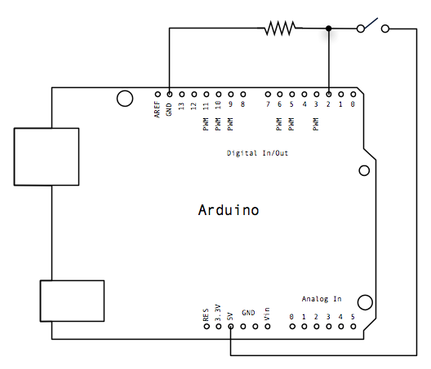

ARDUINO CODE:

1. //Constants

const int buttonPin = 4;

const int ledPin = 3;

//Variables

int buttonState = 0;

int flag=0;

void setup() {

//Input or output?

pinMode(ledPin, OUTPUT);

pinMode(buttonPin, INPUT_PULLUP);

}

void loop(){

//Read button state (pressed or not pressed?)

buttonState = digitalRead(buttonPin);

if (buttonState == LOW) {

//...ones, turn led on!

if ( flag == 0){

digitalWrite(ledPin, HIGH);

flag=1; //change flag variable

}

//...twice, turn led off!

else if ( flag == 1){

digitalWrite(ledPin, LOW);

flag=0; //change flag variable again

}

}

delay(200); //Small delay

}

1. /*Using a Single Button, create mutliple options based on how long the button is pressed

The circuit:

* LED attached from pin 13 to ground through a 220 ohm resistor

* LED attached from pin 12 to ground through a 220 ohm resistor

* one side of momentary pushbutton attached to pin 2

* other side of momentary pushbutton attached to Ground

* Note 1: on most Arduinos there is already an LED on the board

attached to pin 13.

* Note 2: In this circuit, when the button is pressed, Ground Voltage is what will be applied.

Created DEC 2014 by Scuba Steve

Modified JAN 2015 by Michael James

Both members of https://programmingelectronics.com

This code is in the public domain

*/

/////////Declare and Initialize Variables////////////////////////////

//We need to track how long the momentary pushbutton is held in order to execute different commands

//This value will be recorded in seconds

float pressLength_milliSeconds = 0;

// Define the *minimum* length of time, in milli-seconds, that the button must be pressed for a particular option to occur

int optionOne_milliSeconds = 1;

int optionTwo_milliSeconds = 20;

//The Pin your button is attached to

int buttonPin = 2;

//Pin your LEDs are attached to

int ledPin_Option_1 = 13;

int ledPin_Option_2 = 12;

void setup(){

// Initialize the pushbutton pin as an input pullup

// Keep in mind, when pin 2 has ground voltage applied, we know the button is being pressed

pinMode(buttonPin, INPUT_PULLUP);

//set the LEDs pins as outputs

pinMode(ledPin_Option_1, OUTPUT);

pinMode(ledPin_Option_2, OUTPUT);

//Start serial communication - for debugging purposes only

Serial.begin(9600);

} // close setup

void loop() {

//Record *roughly* the tenths of seconds the button in being held down

while (digitalRead(buttonPin) == LOW ){

delay(100); //if you want more resolution, lower this number

pressLength_milliSeconds = pressLength_milliSeconds + 1;

//display how long button is has been held

Serial.print("ms = ");

Serial.println(pressLength_milliSeconds);

}//close while

//Different if-else conditions are triggered based on the length of the button press

//Start with the longest time option first

//Option 2 - Execute the second option if the button is held for the correct amount of time

if (pressLength_milliSeconds >= optionTwo_milliSeconds){

digitalWrite(ledPin_Option_2, HIGH);

}

//option 1 - Execute the first option if the button is held for the correct amount of time

else if(pressLength_milliSeconds >= optionOne_milliSeconds){

digitalWrite(ledPin_Option_1, HIGH);

}//close if options

//every time through the loop, we need to reset the pressLength_Seconds counter

pressLength_milliSeconds = 0;

} // close void loop

RESULT: You will see the led is on when the push button is pressed and aging press the push button led is off.

## TRAFFIC LIGHTS

AIM: Write a program for blinking 3 LED’s one after the other.

Description: Traffic Lights are used to control the vehicular traffic. That’s why traffic lights are used to avoid the traffic jams and accidents. There are three lights in the traffic signal, having different message for the drivers. Red light instruct the driver to stop, green light instruct the driver GO through the intersection whereas the yellow light alerts the driver.

Required Equipment:

* Arduino UNO Board
* 3 Resistors
* 3 leds- red-green-yellow
* Jumper Cables

Procedure: The circuit we need to setup is really simple and shouldn’t take you too long to do. Below is a diagram of what you will need to do. If you’re looking a great program to prototype and draw up diagrams, then be sure to check out [Fritzing](http://fritzing.org/home/).

Now we will write some code to bring out lights to life. If you have programming experience, then you will find this code really basic. If you’re new to programming this is a great way to start learning.

First we will need to declare our variables. The GREEN variable represents the pin that the green LED is connected to.

Whilst the DELAY_GREEN variable is the amount of time in milliseconds we will delay the program from moving forward.

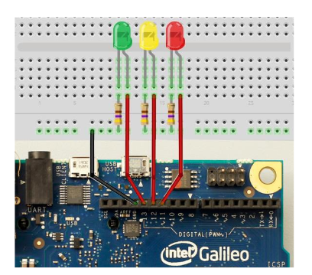

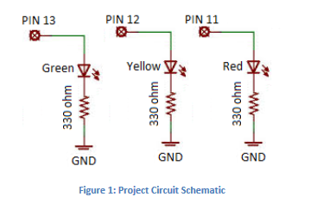

**Arduino code:**

int r=2;

int g=3;

int y=4;

void setup(){

Serial.begin(9600);

pinMode(r,OUTPUT);digitalWrite(r,LOW);

pinMode(g,OUTPUT);digitalWrite(g,LOW);

pinMode(y,OUTPUT);digitalWrite(y,LOW);

}void traffic()

{

digitalWrite(g,HIGH);

Serial.println("green LED:ON,GO");

delay(5000);

digitalWrite(y,HIGH);

Serial.println("Green LED:OFF,yellow LED:ON,WAIT");

delay(5000);

digitalWrite(y,LOW);

digitalWrite(r,HIGH);

Serial.println("Yellow LED:OFF,red LED:ON,STOP");

delay(7000);

digitalWrite(r,LOW);

Serial.println("ALL OFF");

}

void loop()

{

traffic();

delay(10000);

}

int redLedDelay=10000;

int greenLedDelay=10000;

int redLed=7;

int yellowLed=6;

int greenLed=4;

void setup()

{

pinMode(redLed,OUTPUT);

pinMode(yellowLed,OUTPUT);

pinMode(greenLed,OUTPUT);

}

void loop()

{

digitalWrite(redLed,HIGH);

delay(redLedDelay);

digitalWrite(yellowLed,HIGH);

delay(2000);

digitalWrite(redLed,LOW);

digitalWrite(yellowLed,LOW);

digitalWrite(greenLed,HIGH);

delay(greenLedDelay);

digitalWrite(yellowLed,HIGH);

digitalWrite(greenLed,LOW);

delay(2000);

digitalWrite(yellowLed,LOW);

}

3.

// variables

int GREEN = 3;  
int YELOW = 4;  
int RED = 5;  
int DELAY_GREEN = 1000;  
int DELAY_YELLOW = 1000;  
int DELAY_RED = 1000;  
  
// basic functions  
void**setup**()  
{  
  // setup LED modes  
  // we're specifying that we're going to send information to this LED   
  pinMode(GREEN, OUTPUT);  
  pinMode(YELLOW, OUTPUT);  
  pinMode(RED, OUTPUT);  
}  
  
void**loop**()  
{  
  // High turns things on  
  // Low turns things off  
  digitalWrite(GREEN, HIGH);  
  digitalWrite(YELLOW, LOW);  
  digitalWrite(RED, LOW);  
  // how long we want the green led on  
  delay(DELAY_GREEN);  
    
  digitalWrite(GREEN, LOW);  
  digitalWrite(YELLOW, HIGH);  
  digitalWrite(RED, LOW);  
  // how long we want the yellow led on  
  delay(DELAY_YELLOW);  
  
  digitalWrite(GREEN, LOW);  
  digitalWrite(YELLOW, LOW);  
  digitalWrite(RED, HIGH);  
  // how long we want the red led on  
  delay(DELAY_RED);  
}

**ANNAMACHARYA INSTITUTE OF TECHNOLOGY AND SCIENCES**

**(AUTONOMOUS)**

**CERTIFICATE**

Department of **Computer Science and Engineering**

**Hall Ticket Number** …………..………………………..

Certified that this is a bonafide record of practical work done by the candidate Mr/Ms…………….…..………..……….of **B.Tech Computer Science and Engineering** in…………………………………………..laboratory during the academic year 2017-2018.

No. of Experiments Performed

MARKS AWARDED

No. of Experiments Prescribed

**Date: Head of the Department Lab-incharge**

Submitted for the practical Examination held on …………..…………….

**Internal Examiner                                                  External Examiner**